Facility Reservations
Setup Guide
Last Updated: 1/13/2015 by Jonathan Ibasitas

- User Login
  - Your program administrator will create a user account for you. Your user account must have the appropriate settings for you to use the facility reservation modules.
  - Do not share your user account with anyone. The system has no limit or license fees per user account. Each employee using the system should have their own user account.
  - Passwords
    - Do not share your passwords with anyone
    - For PCI Compliance all user passwords must follow certain rules when being created:
      - Must be 8-15 characters in length
      - Must contain at least one lower case letter AND contain 2 of the following conditions:
        - Uppercase letter
        - Number
        - Special Character
    - If you forget your password, contact your program administrator and they can reset it for you.

- Rooms and Areas
  - 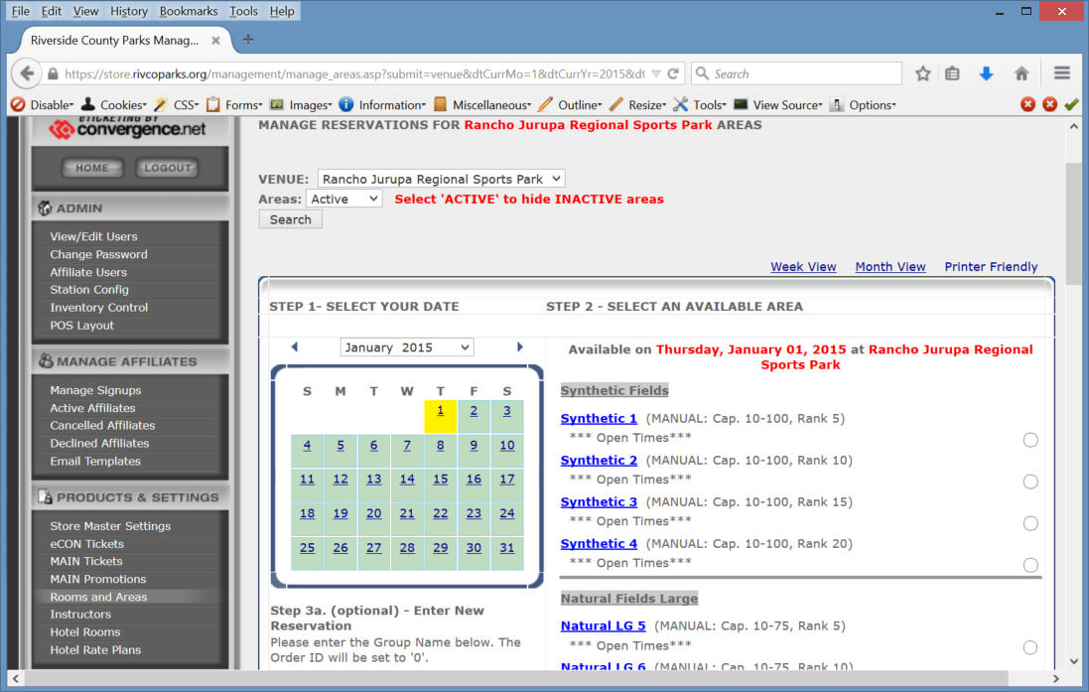
  - This is where you add or edit the facilities you want to rent out.
  - The system contains Locations and Areas. For example, in screen shot above, you have a location called, “Synthetic Fields”. Underneath that location you have areas “Synthetic 1, Synthetic 2, Synthetic 3, and Synthetic 4.
  - You can have any number of Locations and any number of Areas defined in the system.
  - On this page you can manually reserve an area if you wish.
    - To do so, click on the option button to the right of the area you’d like to manually reserve. Next, enter a name in the name field and then click on the “Enter Reservation” button.
    - Manual reservations will remove the area for the selected date/time from availability should someone try to reserve the area in the system.

- Econ Tickets
  - 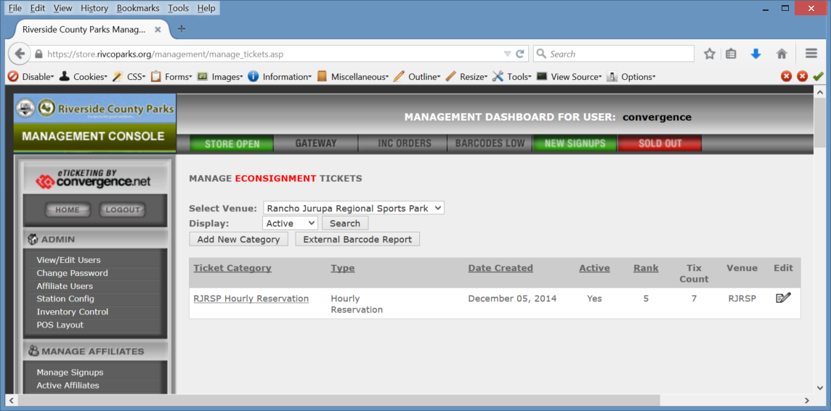
  - There needs to be a category defined under Econ Tickets.
    - The category type must be set to type Hourly Reservation
    - 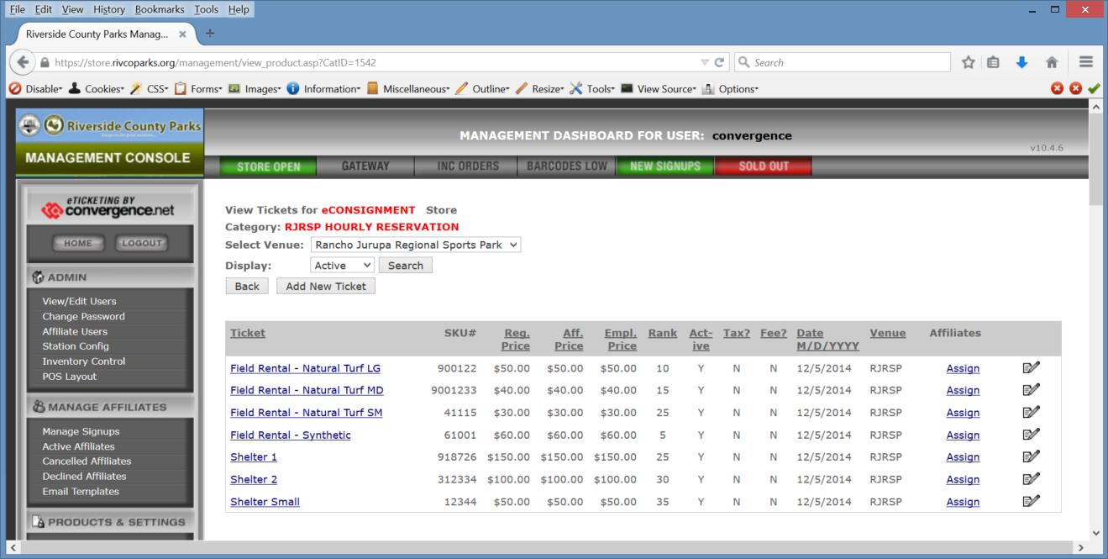
    - You will want to have a product defined for each facility type you want to rent out.
    - The category and products will be set up by your program administrator and Convergence Project Manager.

- Affiliate Groups
  - 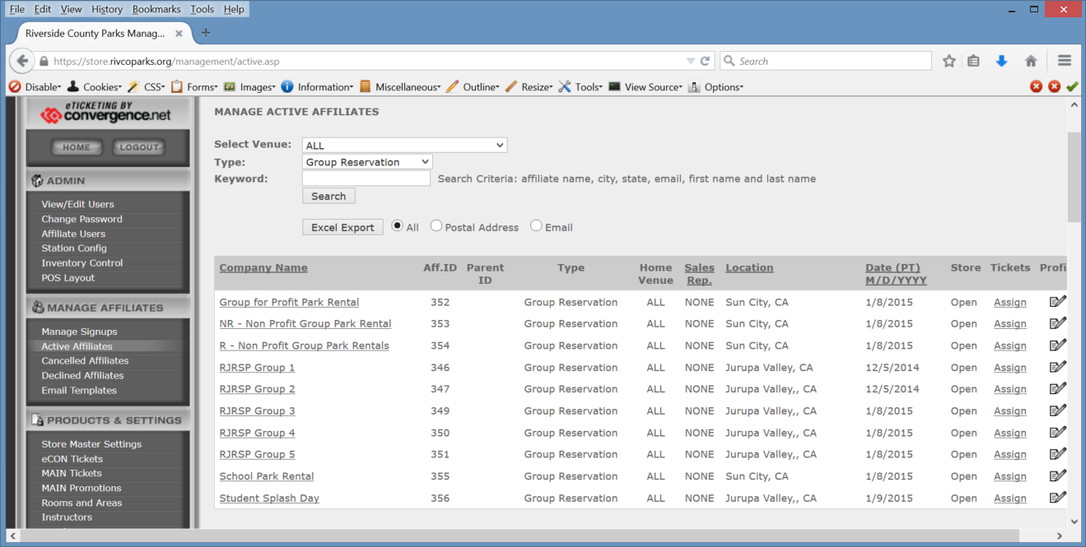
  - Your Program Administrator and Convergence Project Manager will set up the affiliate groups needed for facility reservations.
  - 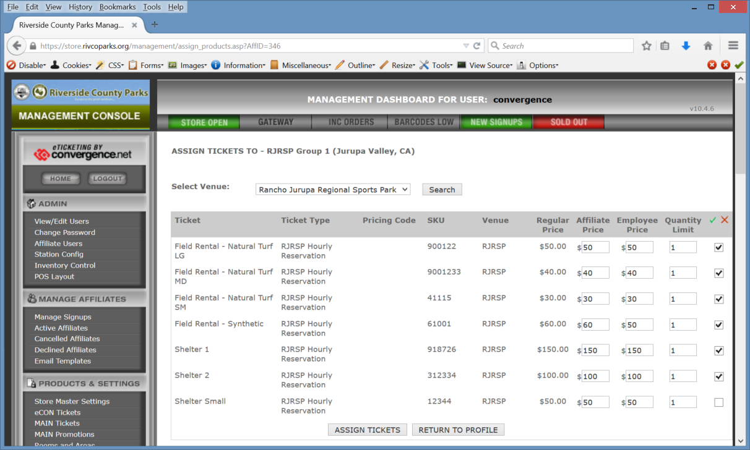
  - Affiliate Groups are used to determine what pricing tier to attach to a facility reservation. You can have as many Affiliate Groups as you’d like.

- Reservation Monthly Report
  - 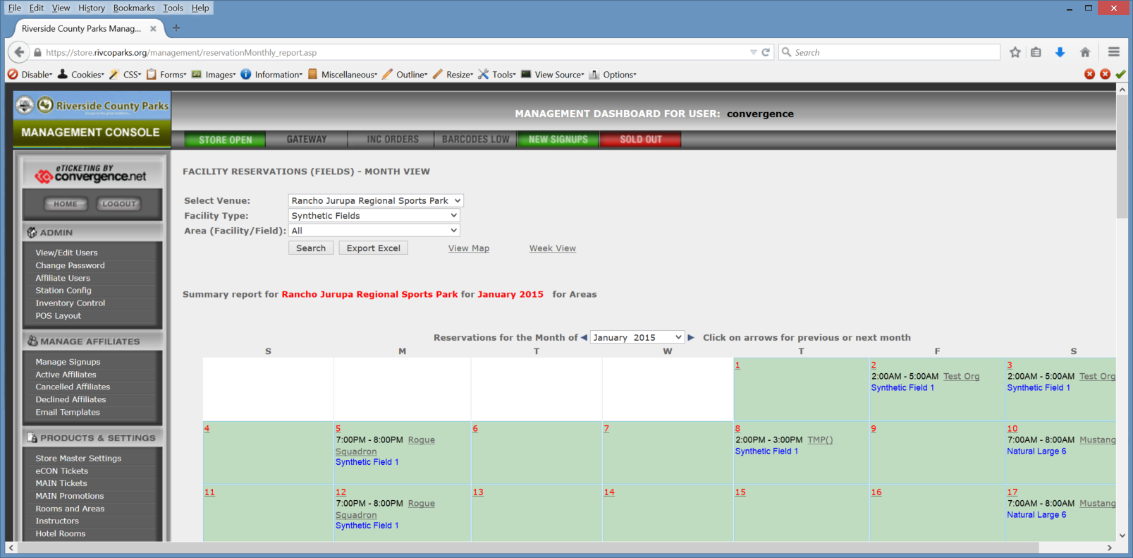
  - The Reservation Monthly Report is where you go to view current and temporary facility reservations in the system.
  - 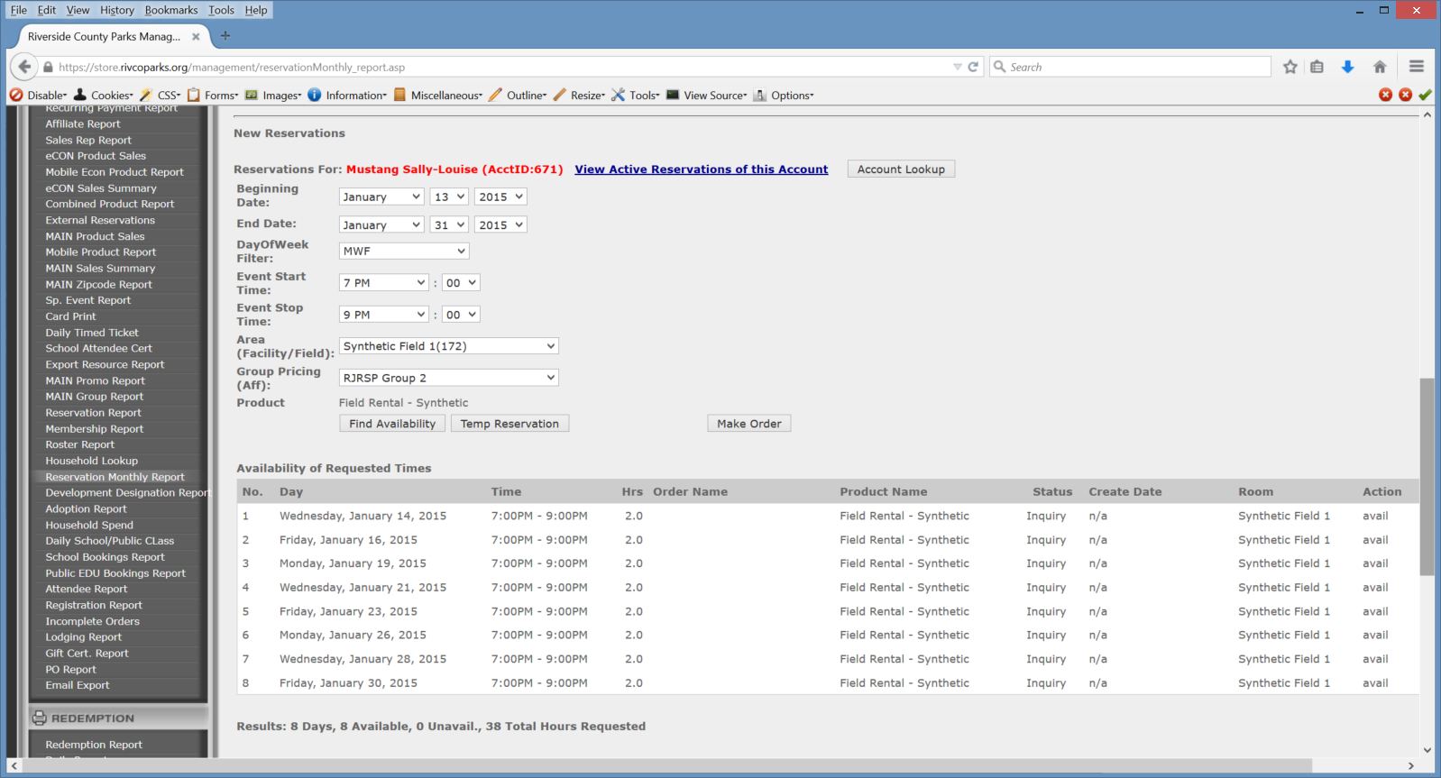
  - You can also find availability and do temp reservations as well as make a reservation

- Making a Reservation.
  - Step 1 – Log into the management dashboard at store.rivcoparks.org
  - Step 2 – Click on Reservation Monthly Report
  - Step 3 – Under “New Reservations”, click on Account Lookup
  - 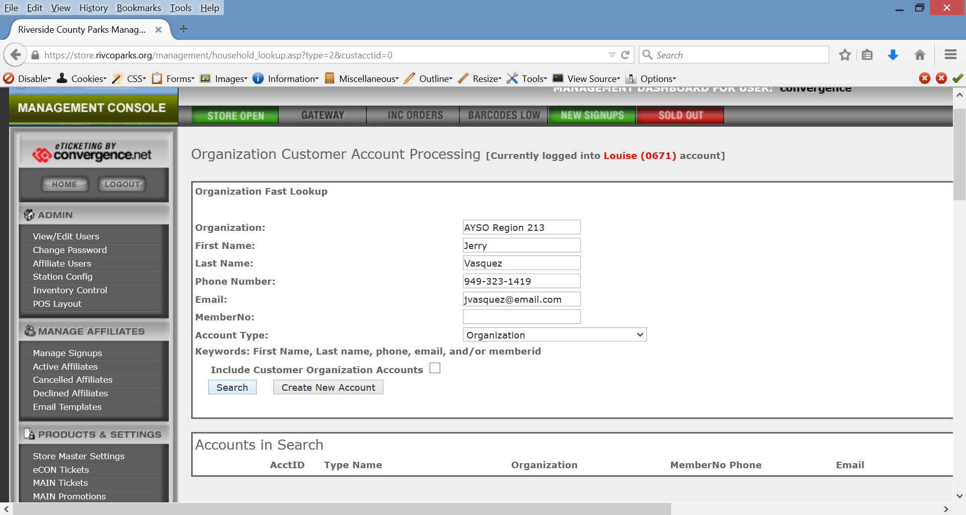
  - Step 4 – Determine if the customer is new or a returning customer. If they are returning, they may already have a household or organization account. If so, type in their organization name and click on the “Search” button. In the Accounts in Search results click on the “Select” button.
    - If they are a new customer/organization, fill out the fields and click on “Create New Account”. Fill out the fields and save the account.
  - 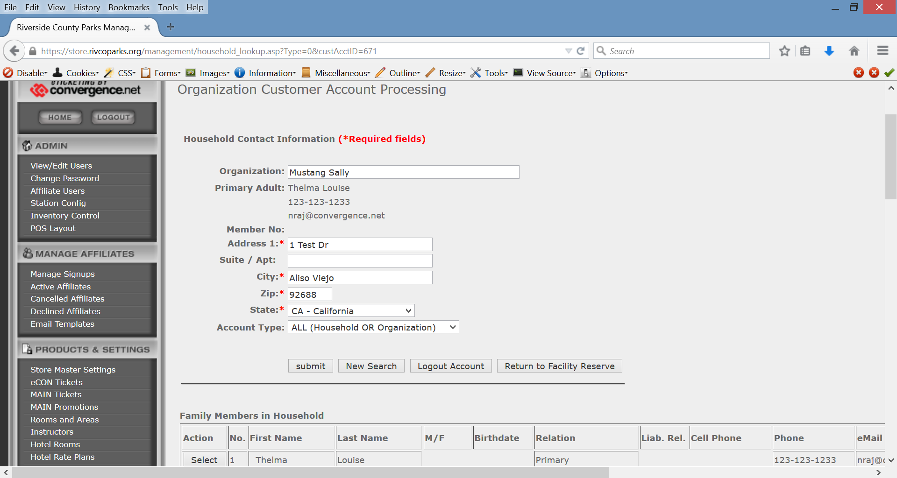
  - Step 5 - Click on “Return to Facility Reserve”
  - Step 6 – Click on the Facility Type drop-down and select a facility type. Then hit the search button.
  - Step 7 – Scroll down to the bottom half of the page and fill out the reservation form fields.
    - Select Beginning Date
    - Select End Date
    - Select DayOfWeek
    - Choose a start time
    - Choose a stop time
    - Slect an Area (Facility/Field)
    - Choose which Group Pricing to use.
    - Click on the “Find Availability” button
    - You will be presented with the availability of each time slot. Next, click on the “Temp Reservation” button. This will put the time slots and fields on hold.
  - Step 8 – Click on the “Make Order” button. This will send you to the front end shopping cart.
  - 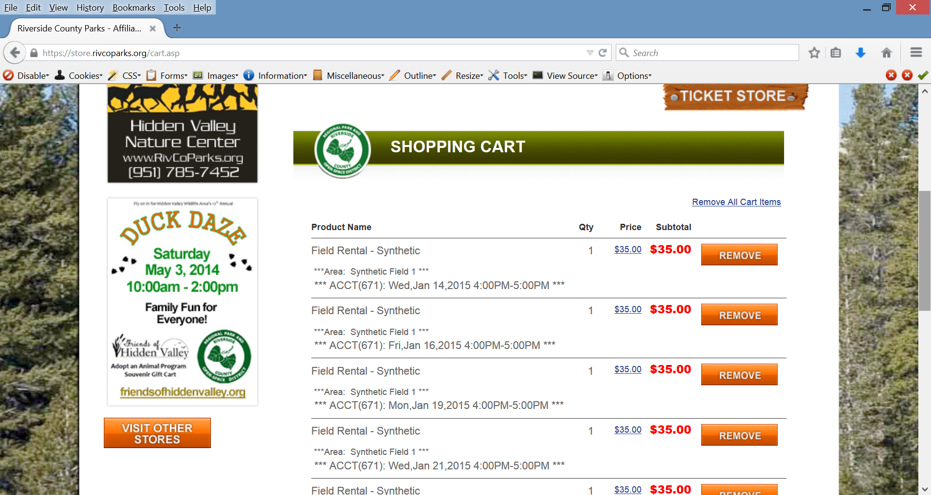
  - Remove any items from the cart you don’t wish to include in the reservation. Next, click on the Checkout button.
  - 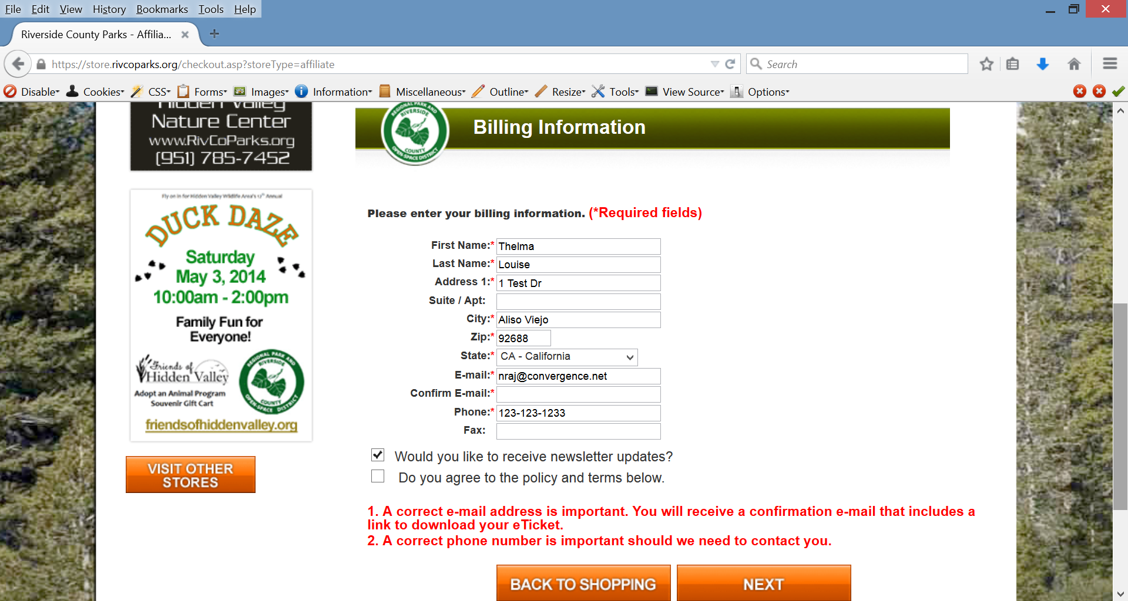
  - Validate the information on the Billing Information screen and then click on the “Next” button.
  - 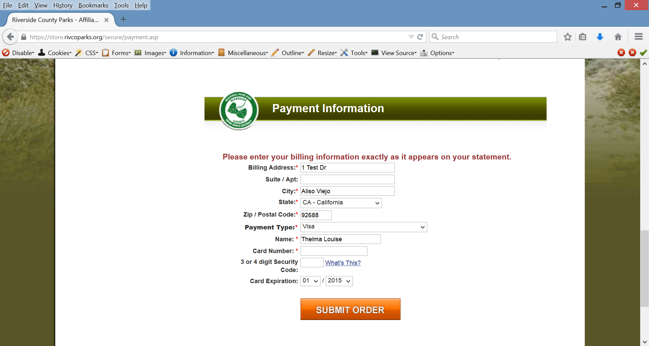
  - Enter the payment information for the customer and then click on the “Submit Order” button.
    - You can place the order into pending. Click on the Payment Type drop-down to see available options. You will see options for “Check” and “Pending (unknown). This will allow you to complete the reservation and then take payments through the back-office at a later time.
  - 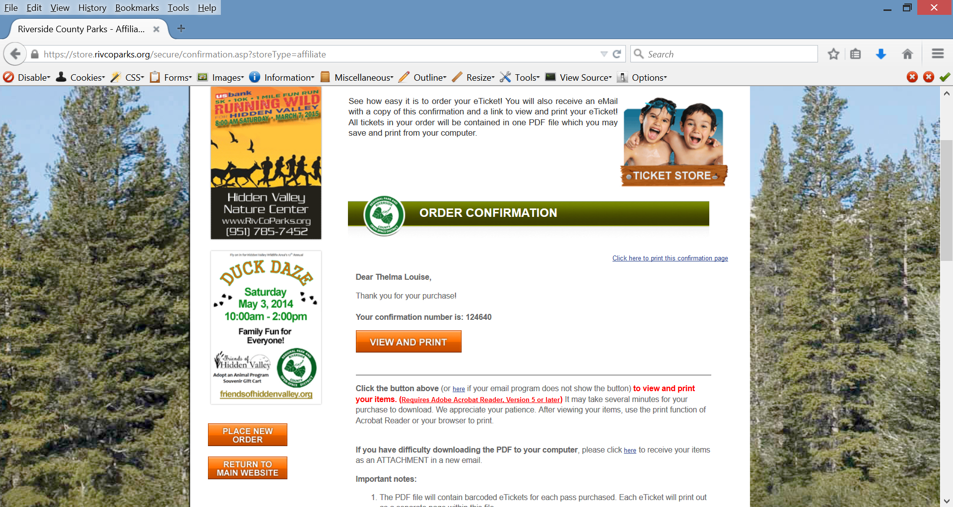
  - The confirmation page will signify that the reservation has been completed. If the customer did not pay in full, they will need to make payments via the back office management page in the Order Detail. Click on the “View and Print” button to view any contract and invoice PDFs.

- Reservation Detail Page
  - You can review the order details of the reservation by logging back into the management dashboard. (TIP: you can click on your username in the top right of the front-end page to get back in).
  - You can go back to the Reservation Monthly Report and then locate the reservation on the calender, click Organization Name on the Date of the reservation. This will send your to the Reservation Details.
  - 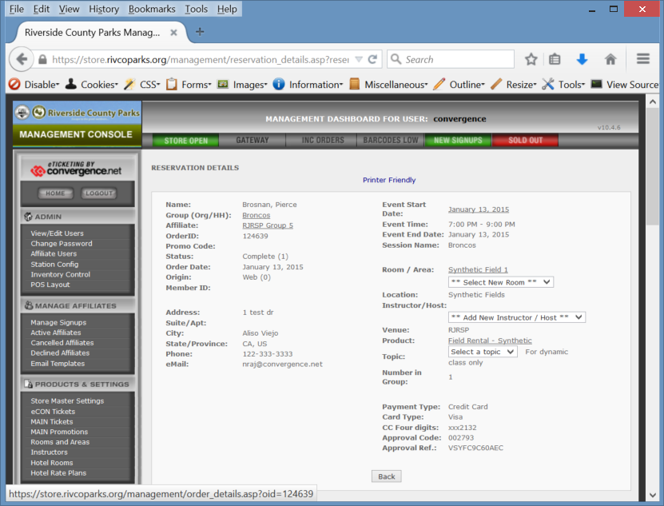
  - Click on the Order ID and you will be send to the Order Detail page.

- Order Detail Page
  - The order detail page will give you the details of the order. You will also be able to make payments to the order (if the customer hasn’t paid in full). On this page you will also be able to open the contract/invoice PDF by clicking on the “View all eTickets” button in the eTicket Control Panel.

  - 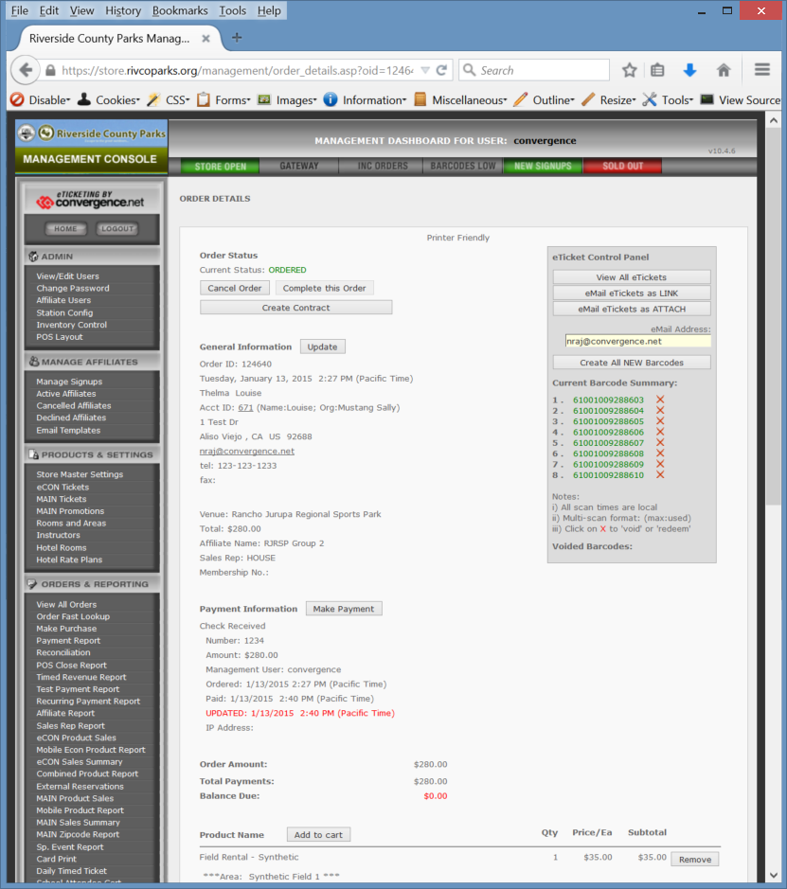

  - For instructions on making payments to a pending order please review items 12 through 17 in the document Process Instruction – Pending Order.

