Suppressing Affiliate Prices from an Affiliate Dashboard

Author: Jonathan Ibasitas Software Version: 12.4.2 Last Updated: 12/1/2016

We have added the capability to suppress affiliate pricing from the affiliate dashboard reports on a per affiliate basis.
Step 1. Log into the management dashboard
Step 2. Click on Active Affiliates. Search for the affiliate you want to suppress affiliate pricing for on their dashboard and go into their affiliate profile page.
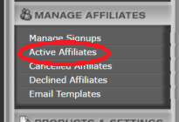

Step 3. On the affiliate profile page, scroll down to the Account Representative Information section. Check the box next to the label that says, “Hide “Affiliate Price” for this affiliate:”.
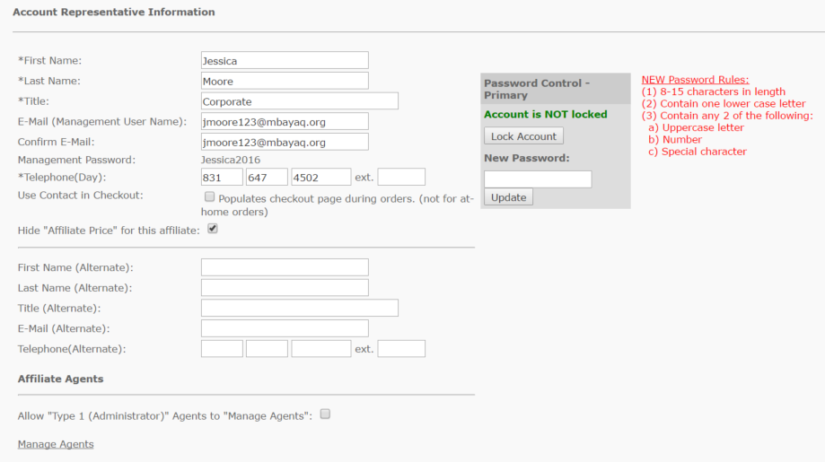

Results
Affiliate Dashboard Reports will no longer display any affiliate price reporting or related (such as commissions, balance due, etc.) for that affiliate. See the following before and after examples.

Balance Report (before suppression)
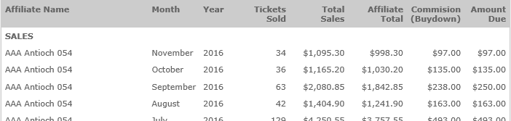

Balance Report (after suppression)
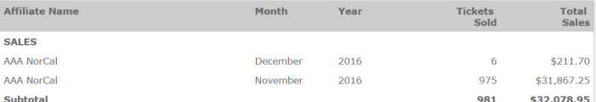

Transaction Detail Report (before suppression)

Transaction Detail Report (after suppression)

Parent Affiliate Statement (before suppression)
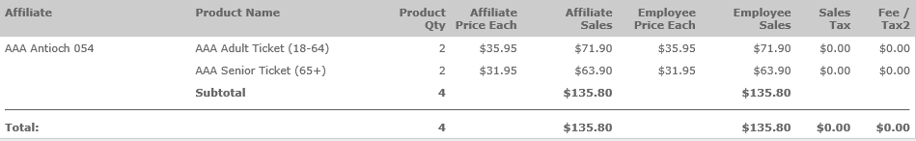

Parent Affiliate Statement (after suppression)
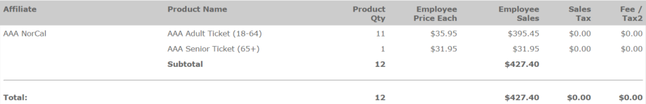

PO Report (before suppression)

PO Report (after suppression)

Contact your Convergence Program Manager if you need further assistance or if you have any questions.

