Affiliate Report Instructions
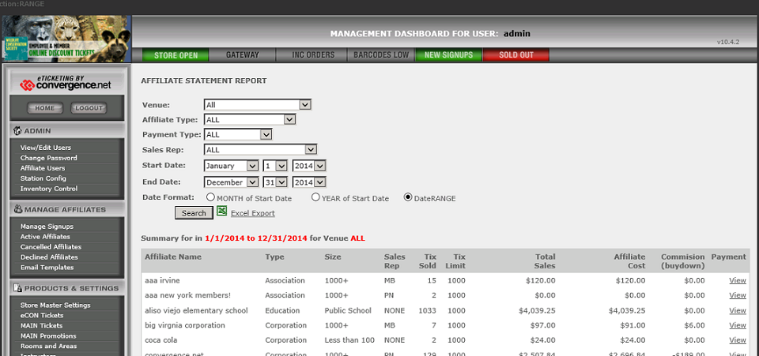

Filters
- Venue – this will let you look at all venues, or individual venues. If you are locked to a specific venue you will not have an option to choose.
- Affiliate Type – You can run the report for particular Affiliate types as pre-determined on the Affiliate set up.
- Payment Type – this enables you to run the report just for Direct Bill Affiliates.
- Sales Rep – this enables you to run the report for individual Sales Reps
- Start Date – This field is important for the filters options later.
- End Date – This field is only used for the DateRange filter.
Format
- MONTH of Start Date – The report will run for the month stipulated in the “Start Date” filter.
- YEAR of Start Date – The report will run for the year stipulated in the “Start Date”.
- DateRANGE – The report will run for the date range stipulated.
Balance Report
This is accessed via the “View” link underneath the Payment column in the Affiliate Report.
This report runs for the month and year stipulated in the “Start Date” on the Affiliate report, and all months prior to that date. Eg. You want to run the report for 2014.
- In the Affiliate report, use all the filters you need to pull the Affiliates/reps etc you need.
- In the “Start Date” make sure the month and year stipulated is December 2014. The day does not matter. The End Date can be left as is. The format does not matter. But if you set the format to YEAR of Start Date then the numbers will match across the two reports.
- Click Search.
- If you click on View now you will see Sales for December 2014 and all prior that the affiliate was in the system.
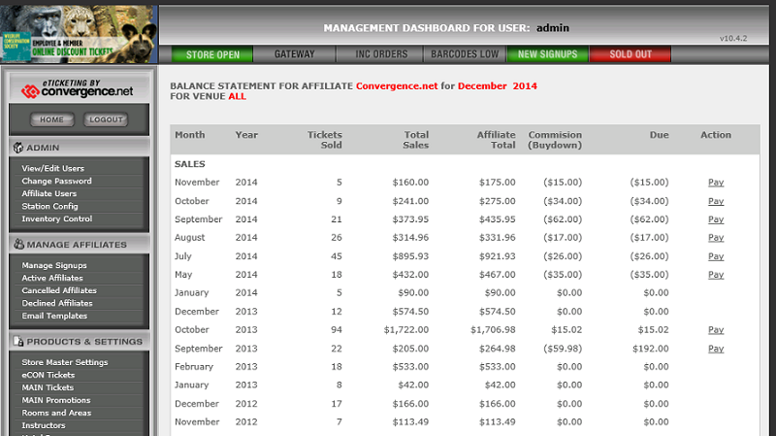
Details
- Total Sales – these are the sales at Employee Price sold during the individual months.
- Affiliate Total – these are the sales at Affiliate Price. If your customer is Direct Bill, this is the number you need to invoice them for the month.
- Commission/(buydown) – This is the difference between the Affiliate total and the employee price. If the Affiliate is pay at purchase then the due amount is the amount that is either due to you because your affiliate is doing a Buydown, or subsidizing the purchase. This is in parenthesis. Or a commission that you owe to your affiliate. No parenthesis on the number.
- Action – we do not operate a full accounting system, but if you wish to monitor which months have been paid, then clicking the Pay button will show that nothing is now due, and will list the payment at the bottom of the screen. Clicking “clear” next to that payment will remove the payment and reinstate the “due’ amount.

