Management within FBR Application

Version 12.2.3 introduced a new manage function
Steps
The header in FBR has a new ‘MANAGE’ link between the user name and the station name

Steps
The current available options are “Scan” and “Previous Orders.” Scan can be used with or without clicking the Scan button. The page will automatically detect a barcode scan of any numeric entry with more than 5 digits. Current Scan options available are:
- Scan an order to bring up the order details
- Scan a barcode to bring up the order details
- Scan a UPC to view product details and return an item without an order.

Previous Orders will list the previous 10 orders under the current user and station.

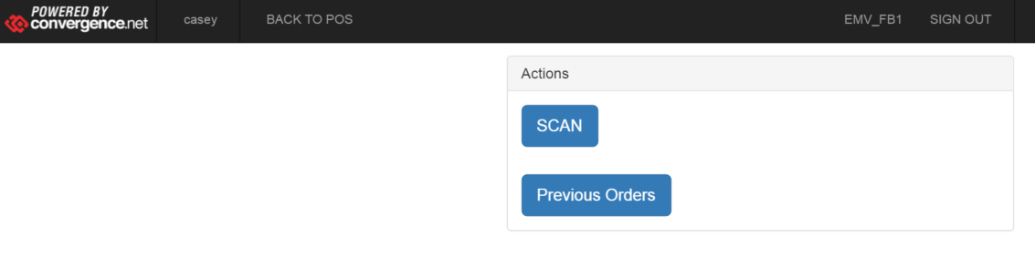

Option | Description
1. Scan a UPC to view product details and bring up order details | This will show the Product Name, Product ID, and Price.  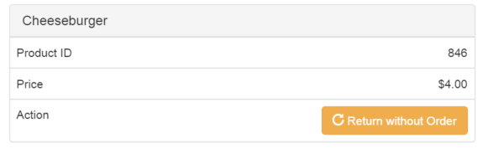
2. Scan an order number of barcode to show order details | This page will show the order cart, totals, payment information, and any order notes.  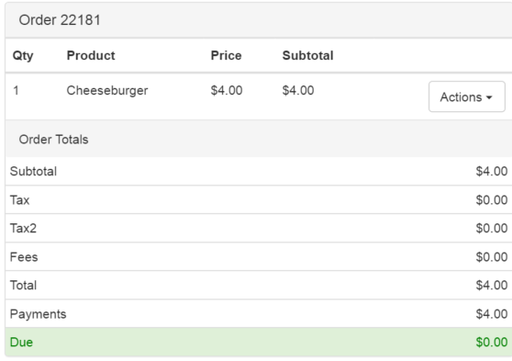  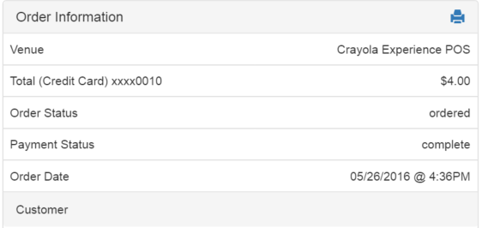
3. Order detail functionality | There are two sets of functionality in the order details page in FBR.  - Item level actions  - Upgrade (GA to membership, based on category)  - Redeem (if not already)  - Return  - Activate (If membership – go to Card print)  - Order level actions  - Print (re-prints receipt and tickets)

Option | Screenshots
4. Previous Orders | 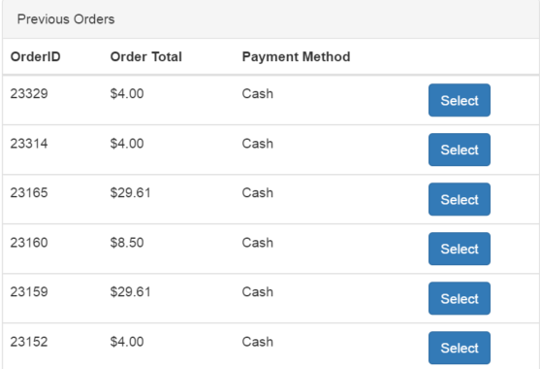Based on the current logged in user and the station. No date/time restrictions.

